OrderSmart®
ICD-10 Conversion

NOTE: This document does not contain PHI
New functionality has been developed within OrderSmart to meet the 10/1/15 requirements for capturing IDC-10 codes. The system will search for and accept both IDC-9 and IDC-10 codes. However, for Date of Service prior to 10/1, the user is directed to select IDC-9 codes and for appointments 10/1 and after, the user is directed to select IDC-10 codes. This applies to both creating an order and screening Medical Necessity as well as ad hoc Medical Necessity checking within OrderSmart.

Placing an order with an IDC-9 Code for service date 10/1/2015 or later

- If a user enters the actual IDC-9 diagnosis code and selects Scheduling Details of “Scheduled” or “To be Scheduled” with an anticipated DOS of 10/1/2015 or later

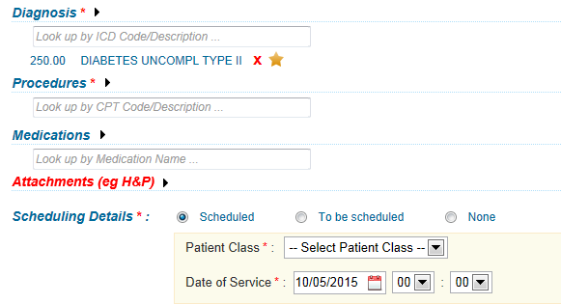

- The following error message will display
- The user will select ok

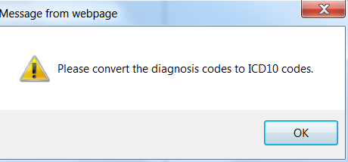

- The user will click on the ICD-9 code to get the alternate IDC-10 codes

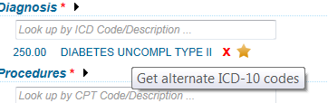
- A conversion pop up from IDC-9 to IDC-10 will display
- The user will check the box next to the IDC-10 code
- Select convert

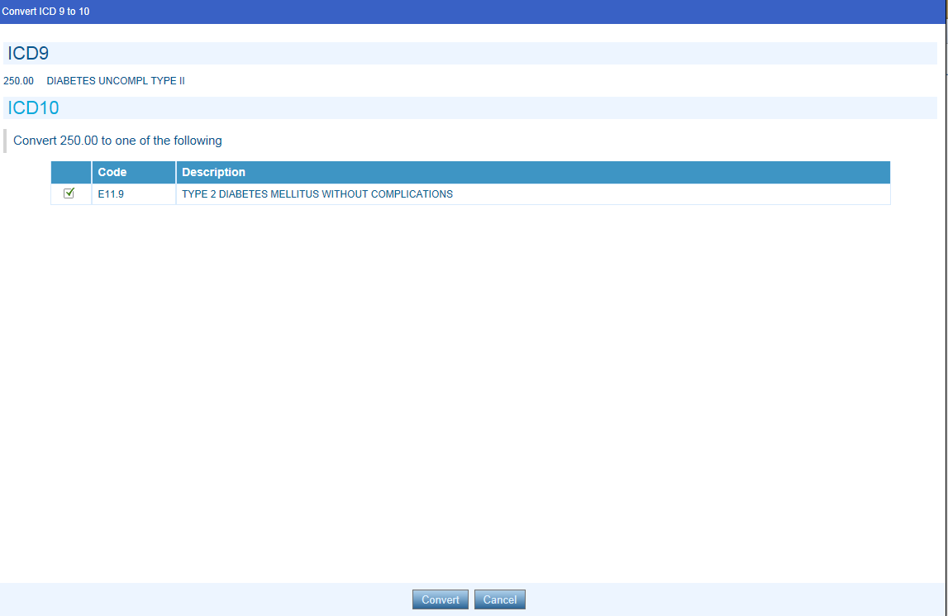

- The converted IDC-10 codes and descriptions will display on the place order screen

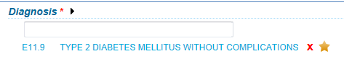

- If the description of the diagnosis code is entered both related IDC-9 and IDC-10 codes will be provided in the scroll down list

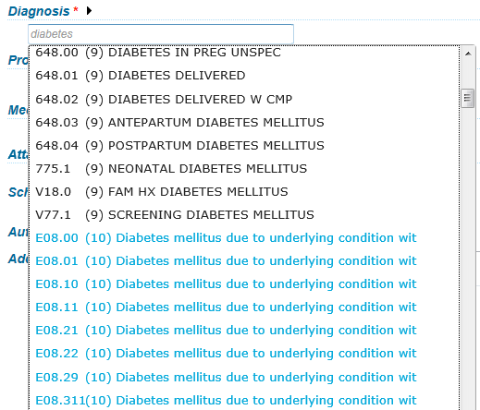

- If the Scheduling Details of “Scheduled” or “To be Scheduled” with an anticipated DOS of 10/1/2015 or greater is populated prior to entering the diagnosis code and an IDC-9 code is entered the system will automatically convert to an IDC-10 code if the codes are a one to one match. If there is not a one-to-one match, a list of codes will display and the user will need to select the correct code as provided by the physician.

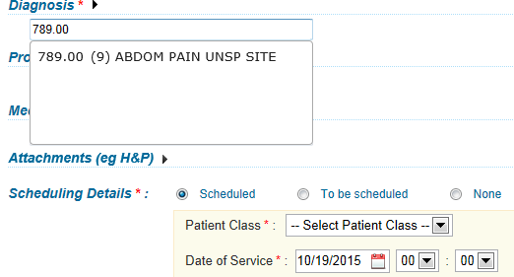
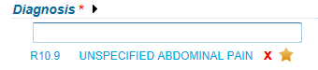

Placing an order with an IDC-10 Code for service date prior to 10/1/2015

- If a user enters an IDC-10 diagnosis code and selects, Scheduling Details of “Scheduled” or “To be Scheduled” with an anticipated DOS prior to 10/1/2015.

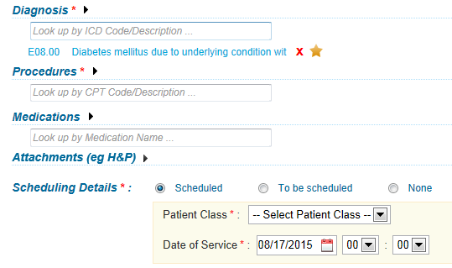

- The following error message will display
- The user will select OK

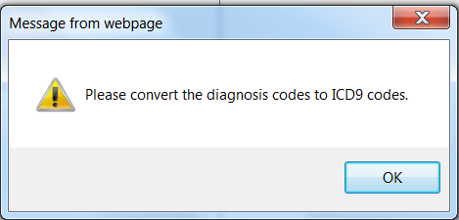

- The user will click on the IDC-10 code to get an alternate IDC-9 code

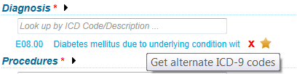

- A conversion pop up from IDC-10 to IDC-9 will display
- The user will check the box next to the IDC-9 code
- Select convert

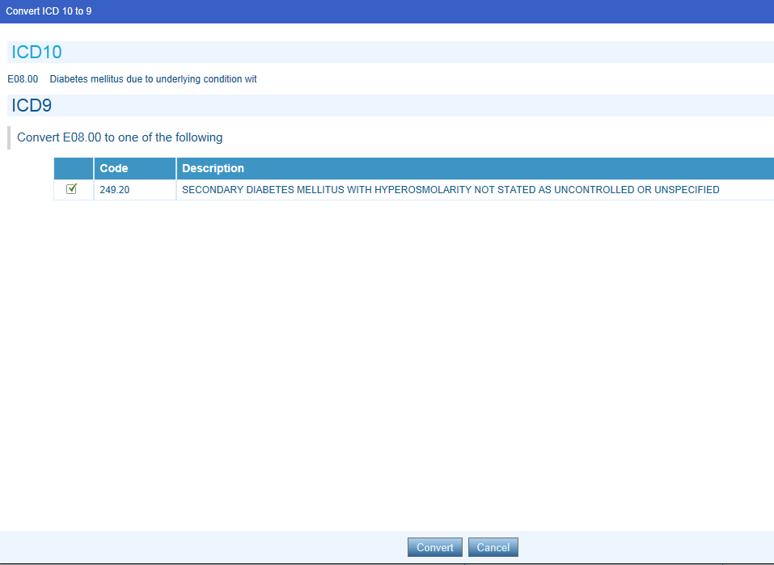

- The converted IDC-10 code and description will display

Medical Necessity screening within OrderSmart

- The IDC-9 to IDC-10 conversion functionality is the same as outlined above when screening for Medical Necessity and ad hoc Medical Necessity checking.

- When checking for Medical Necessity using a 10/1/2015 or later DOS and entering an IDC-9 code, the system will automatically convert to the IDC-10 code if the codes are a one to one match. If there is not a one to one match a list of codes will display and the user will need to select the correct code as provided by the physician.

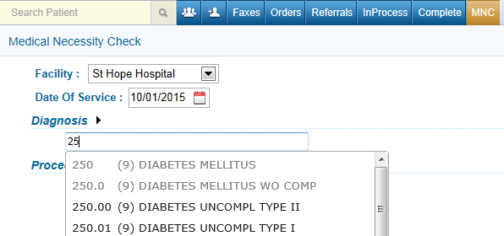

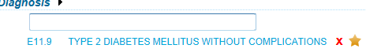

  - When checking for Medical Necessity using a date prior to 10/1/2015 and using an IDC-10 code, the user will receive the following message.
  - Click OK

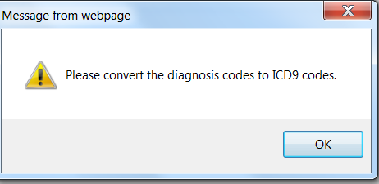

- Click on the IDC-10 code to receive the IDC-10 to IDC-9 conversion
- Check the box next to the code and click on Convert

